[The Pioneer Woman](http://thepioneerwoman.com) [Tasty Kitchen](http://tastykitchen.com)

* [Home](http://tastykitchen.com/)
* [Recipes](http://tastykitchen.com/recipes/)
* [Community](http://tastykitchen.com/recipes/members/)
* [Blog](http://tastykitchen.com/blog/)

Top of Form



Bottom of Form

Top of Form

[Advanced](http://tastykitchen.com/advanced-search/)

Bottom of Form

[Sign Up](http://tastykitchen.com/recipes/register/) [Log In](http://tastykitchen.com/wp-login.php)

[h](mailto:support@tastykitchen.com) [a](https://twitter.com/tastykitchen) [f](https://www.facebook.com/pages/Tasty-Kitchen/174953615895155) [e](http://www.pinterest.com/thepioneerwoman/tasty-kitchen/) [d](http://tastykitchen.com/feed/)

[**Blog**](http://tastykitchen.com/blog/)

* [Baking](http://tastykitchen.com/blog/category/baking/)
* [Holidays](http://tastykitchen.com/blog/category/holiday-treats/)
* [Kitchen Talk](http://tastykitchen.com/blog/category/kitchen-talk/)
* [Looks Delicious!](http://tastykitchen.com/blog/category/looks-delicious/)
* [Meet the Member!](http://tastykitchen.com/blog/category/meet-the-member/)
* [Miscellaneous](http://tastykitchen.com/blog/category/miscellaneous/)
* [Step-by-Step Recipes](http://tastykitchen.com/blog/category/step-by-step-recipes/)
* [The Theme Is…](http://tastykitchen.com/blog/category/the-theme-is/)

**Recently**

* [Prev](http://tastykitchen.com/blog/2011/04/old-fashioned-oatmeal-cake/)
* [Next](http://tastykitchen.com/blog/2011/04/old-fashioned-oatmeal-cake/)
* [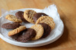](http://tastykitchen.com/blog/2015/09/two-quick-solutions-for-a-sudden-cookie-fix/)
* [](http://tastykitchen.com/blog/2015/09/looks-delicious-basic-granola/)
* [](http://tastykitchen.com/blog/2015/09/cookies-and-cream-donuts/)
* [](http://tastykitchen.com/blog/2015/09/grilled-macadamia-crusted-pineapple-with-coconut-cream/)
* [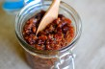](http://tastykitchen.com/blog/2015/08/bacon-jam-ooh-mommy/)
* [](http://tastykitchen.com/blog/2015/08/announcing-food-friends/)
* [](http://tastykitchen.com/blog/2015/08/no-bake-granola-bars/)
* [](http://tastykitchen.com/blog/2015/08/lets-talk-corn/)
* [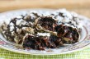](http://tastykitchen.com/blog/2015/08/chocolate-zucchini-cookies/)
* [](http://tastykitchen.com/blog/2015/08/lets-talk-peaches/)
* [](http://tastykitchen.com/blog/2015/08/looks-delicious-roasted-summer-vegetable-ragout/)
* [](http://tastykitchen.com/blog/2015/08/150-gift-card-giveaway/)
* [](http://tastykitchen.com/blog/2015/08/discover-new-fruits-and-vegetables/)
* [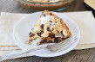](http://tastykitchen.com/blog/2015/08/smores-pie/)
* [](http://tastykitchen.com/blog/2015/08/looks-delicious-trail-mix-chocolate-smoothie/)

Profile photo of ThreeManyCooks

**Apr** 27 2011

[**Old-Fashioned Oatmeal Cake**](http://tastykitchen.com/blog/2011/04/old-fashioned-oatmeal-cake/)

Posted by [ThreeManyCooks](http://tastykitchen.com/blog/author/threemanycooks/) in [Baking](http://tastykitchen.com/blog/category/baking/), [Step-by-Step Recipes](http://tastykitchen.com/blog/category/step-by-step-recipes/)

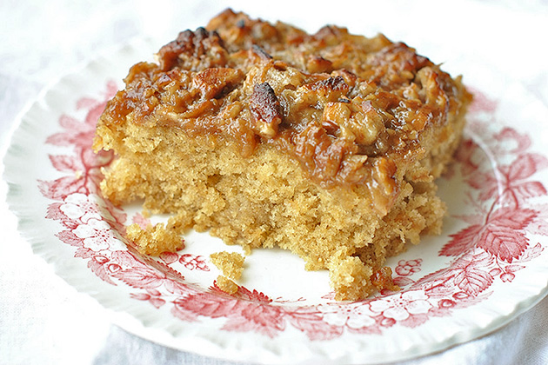

This [Old-fashioned Oatmeal Cake with Broiled Topping](http://tastykitchen.com/tasty-kitchen/recipes/desserts/old-fashioned-oatmeal-cake-with-broiled-topping/) called out to me because I love simple, no fuss cakes that can be thrown together quickly and aren’t overly sweet. But more than the cake, I love the headnote Tasty Kitchen member [Brandi N](http://tastykitchen.com/tasty-kitchen/members/dbnelson/) wrote. She found the hand-written recipe for this cake in her grandmother’s old tin recipe box and said the cake was “oozing with memories” for her. When I read something like that, I know it’s gotta be good.

This cake is delicious. It’s fluffy and moist, and the broiled topping makes it taste like a cinnamon roll. It’s the perfect partner for late-afternoon coffee or tea. Plus if it has oatmeal in it, it’s has to be kind of healthy, right?

   
   
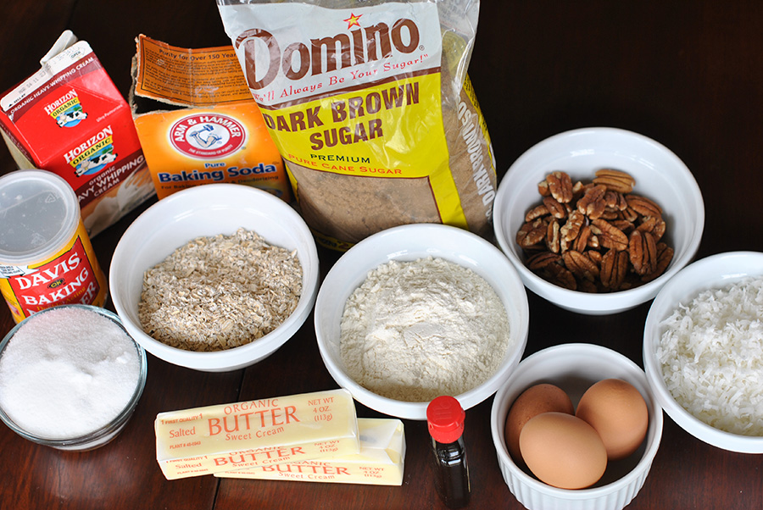

You’ll need quick rolled oats, white sugar, brown sugar, butter, vanilla, eggs, flour, baking soda, baking powder, salt, heavy whipping cream (or half and half), coconut, and pecans.

   
   
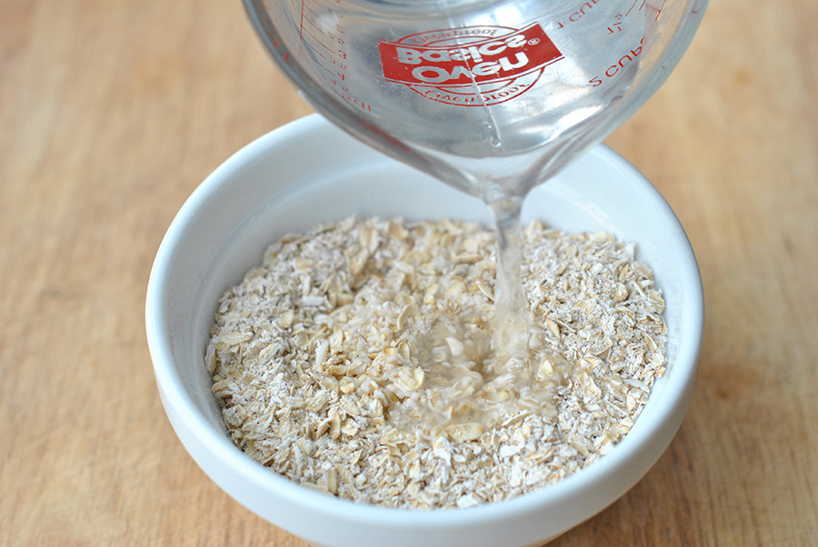

Start by combining quick-cooking oats with the boiling water. (Tip: If you don’t have quick cooking oats, simply food process old-fashioned rolled oats for a few seconds.)

   
   
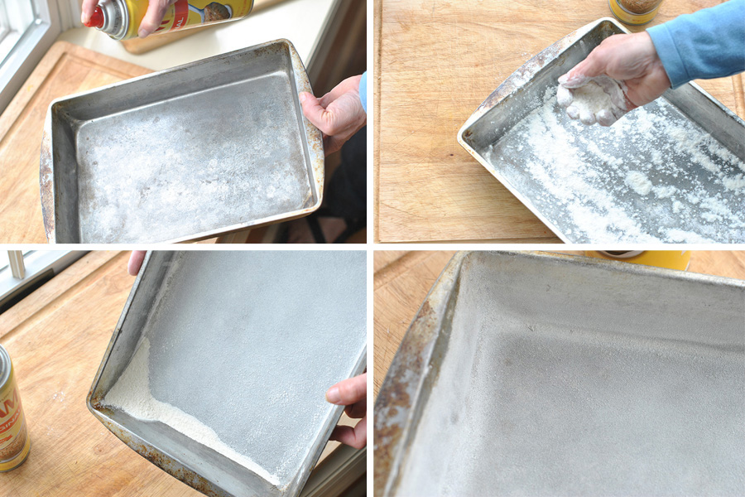

Adjust the oven rack to the lower-middle position and preheat oven to 350 degrees. Coat a 13-by 9-inch pan with vegetable cooking spray and flour.

   
   
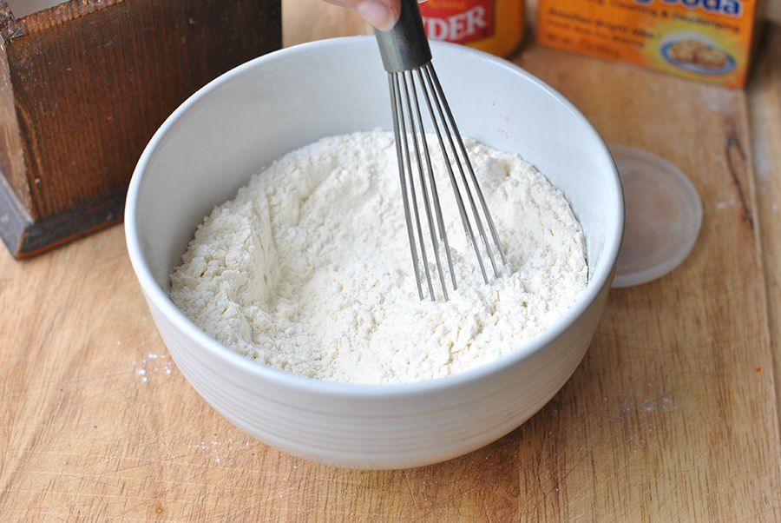

Mix all the dry ingredients in a medium bowl.

   
   
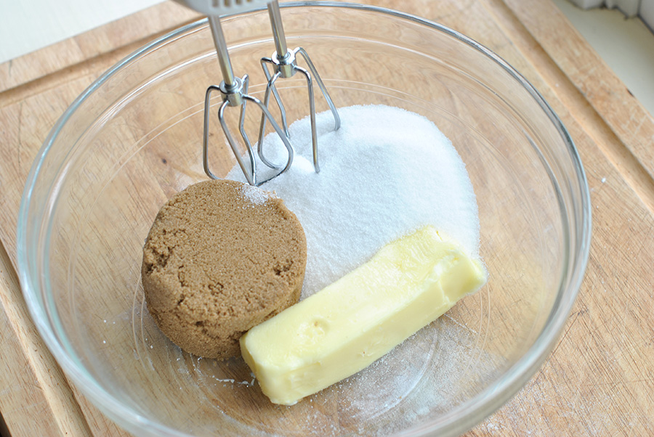

In a large bowl beat the two sugars and butter until light and fluffy.

   
   
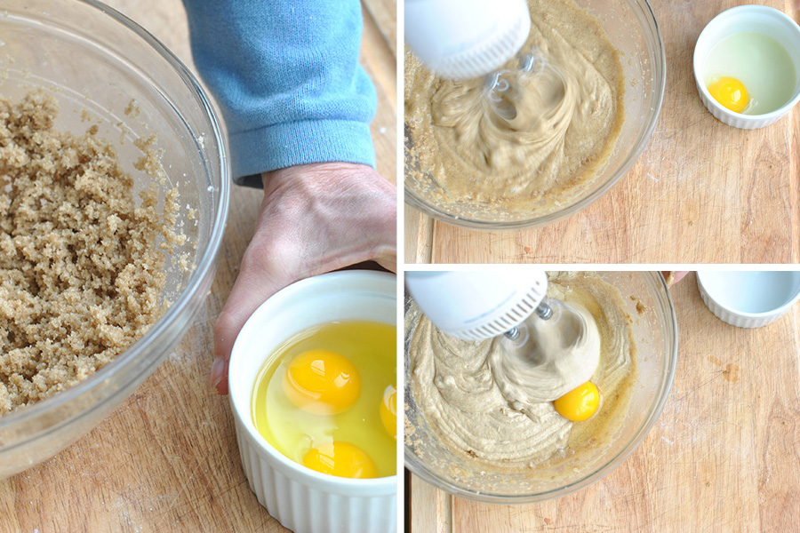

And then the eggs one at a time.

   
   
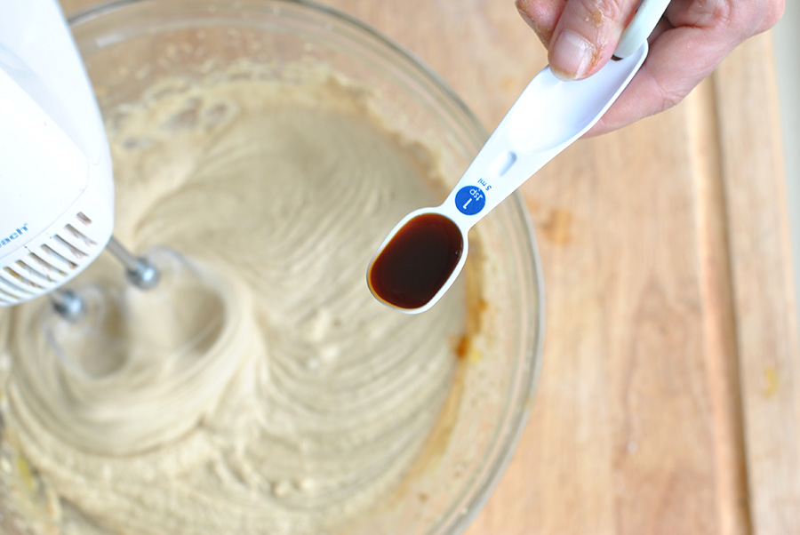

Beat in the vanilla …

   
   
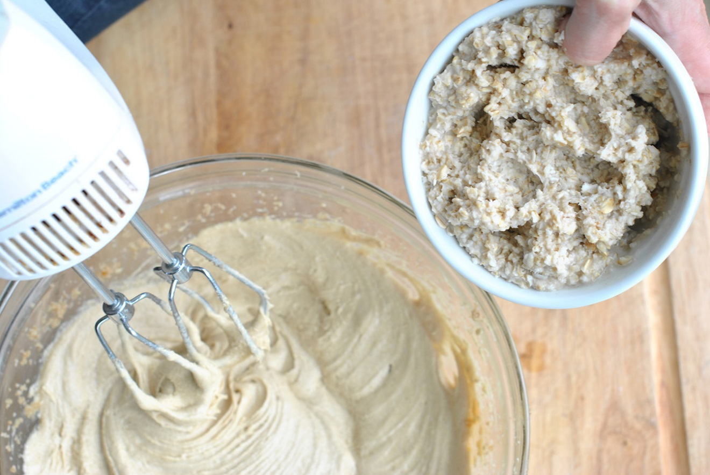

Mix in the oatmeal …

   
   
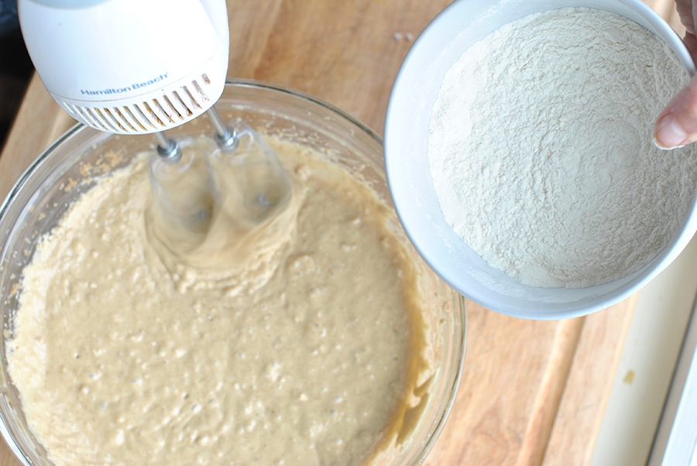

Then finally add in the flour mixture.

   
   
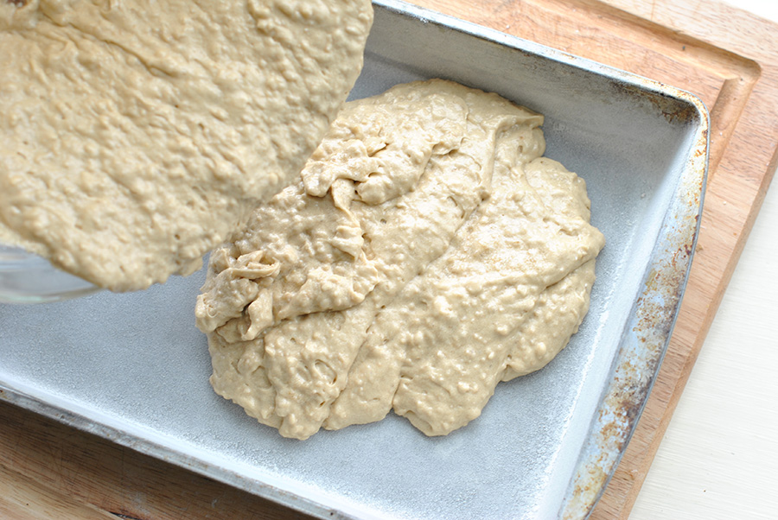  
   
Pour the batter into the prepared pan. Bake until a toothpick inserted in the center comes out clean, 35 to 45 minutes.

   
   
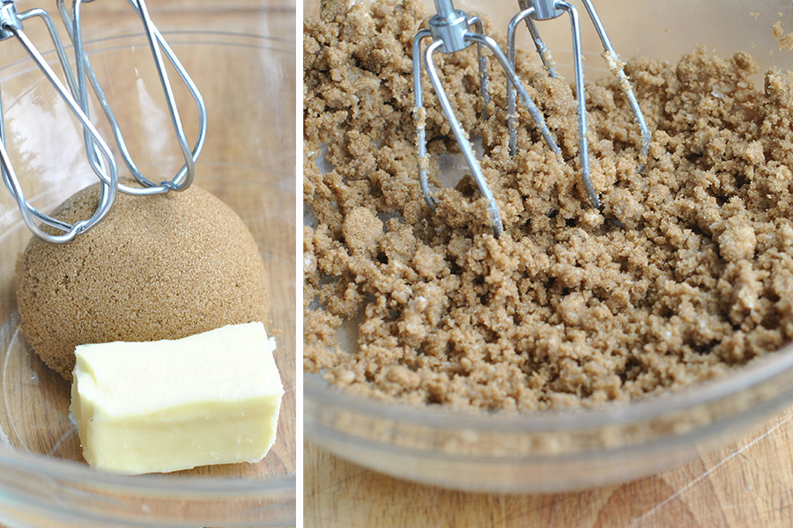  
   
While the cake bakes, beat the remaining brown sugar and butter in a medium bowl.

   
   
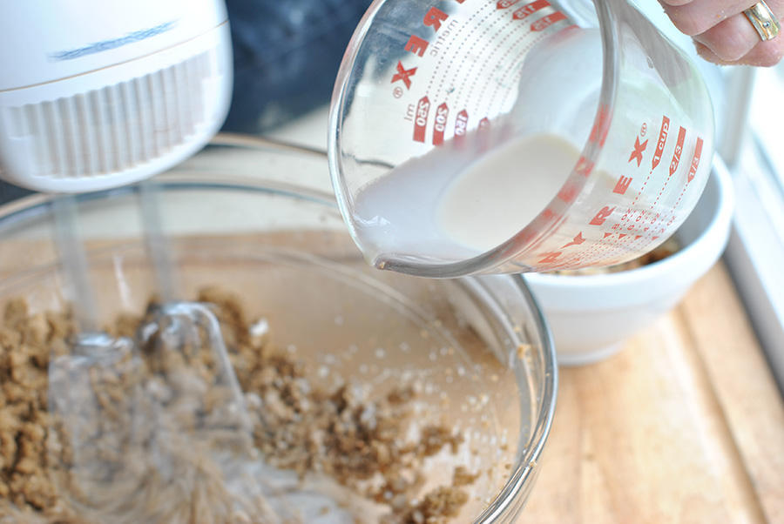

Beat in the cream (or half-and-half) until smooth.

   
   
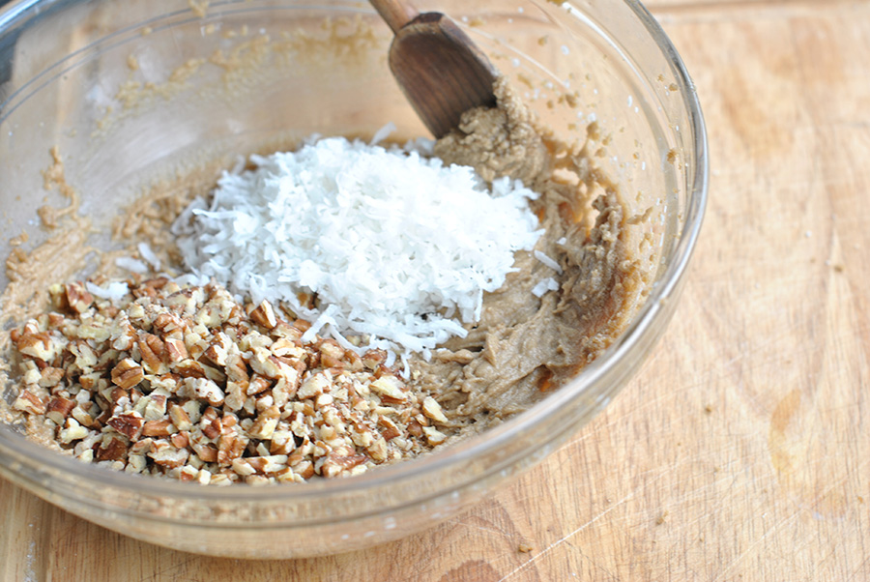

Stir in coconut and pecans.

   
   
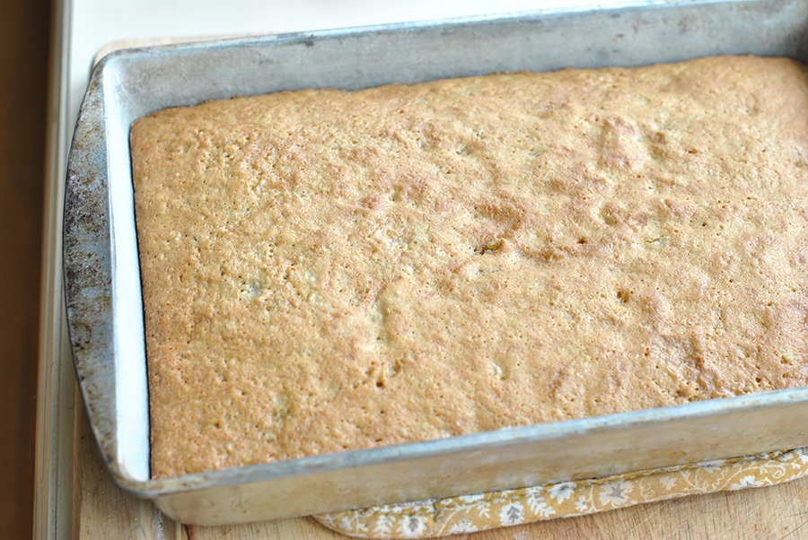

When the cake comes out of the oven, top it with this mixture.

   
   
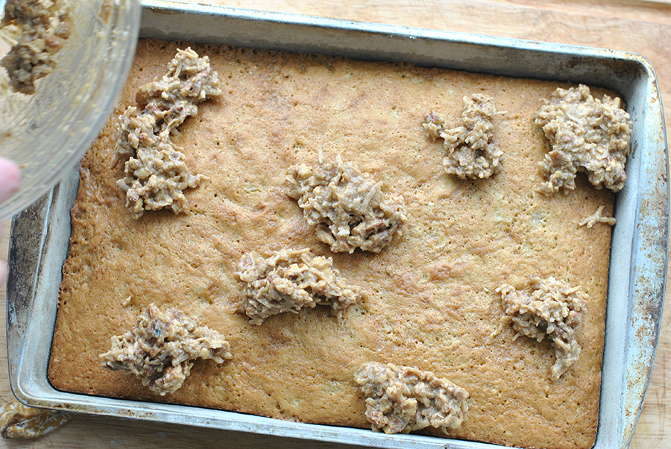

We found it helpful to spoon the topping evenly over the cake …

   
   
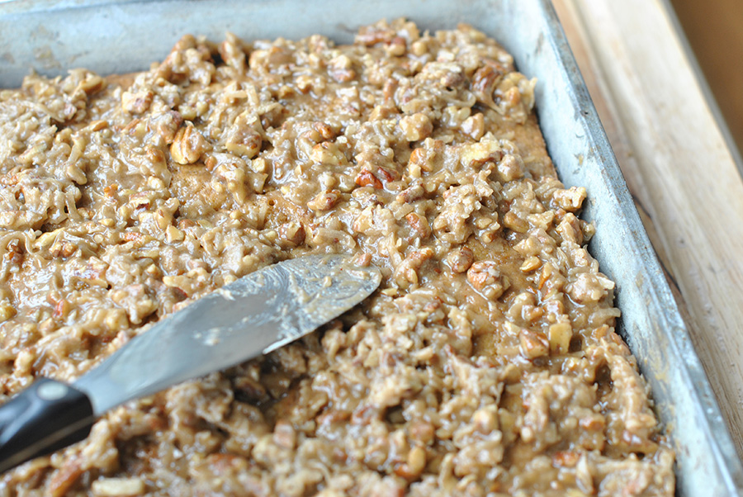

And then spread it to cover.

   
   
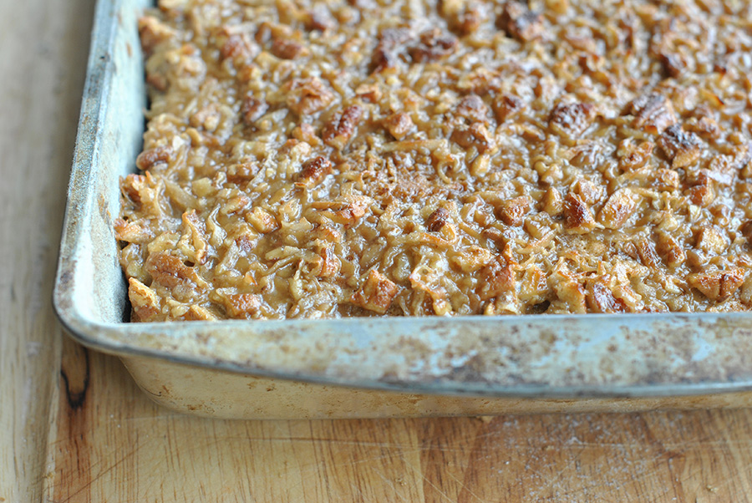  
   
Broil the iced cake 4 to 6 inches from heating element until bubbly and light golden brown, 1 to 2 minutes. Give it a little cooling time (if you can!), then slice, serve, and enjoy!

   
   
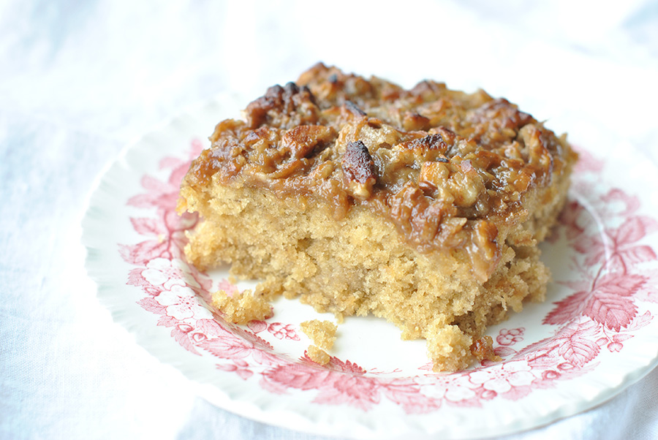

Thank you, [Brandi N](http://tastykitchen.com/tasty-kitchen/members/dbnelson/), for sharing your grandmother’s recipe with us!

   
   
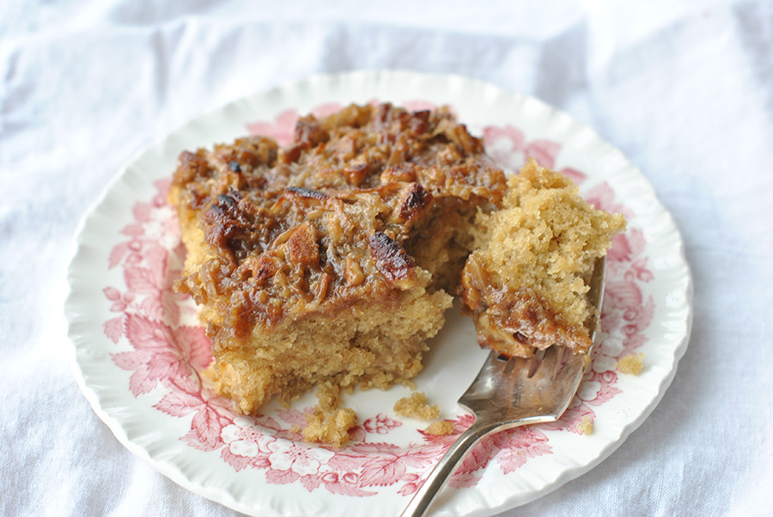

One thing is certain: Brandi’s grandmother knew how to make a good cake. While we have access to more ingredients, techniques, tools (and the internet!), a lot of things were just better back then. This recipe makes me want to pick up the phone and call my own grandmother and ask her for her favorite cake recipe. But I already know what she’ll say. I’ll share that recipe here with you soon.

What were your grandmother’s favorite recipes?

**Printable Recipe**

[**Old-Fashioned Oatmeal Cake with Broiled Topping**](http://tastykitchen.com/recipes/desserts/old-fashioned-oatmeal-cake-with-broiled-topping/)

by [Brandi N](http://tastykitchen.com/recipes/members/dbnelson/) on April 6, 2011 in [Cakes](http://tastykitchen.com/recipes/category/desserts/cakes/), [Desserts](http://tastykitchen.com/recipes/category/desserts/)

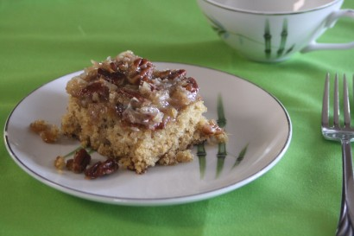

4.75 Mitt(s) 12 Rating(s)12 votes, average: 4.75 out of 512 votes, average: 4.75 out of 512 votes, average: 4.75 out of 512 votes, average: 4.75 out of 512 votes, average: 4.75 out of 5

Top of Form

Prep Time: 30 mins

Cook Time: 35 mins

Difficulty: Easy

Servings: 16

Share [f](http://www.facebook.com/sharer.php?u=http%3A%2F%2Ftastykitchen.com%2Frecipes%2Fdesserts%2Fold-fashioned-oatmeal-cake-with-broiled-topping%2F&t=Old-Fashioned+Oatmeal+Cake+with+Broiled+Topping) [a](http://twitter.com/share?url=http://tastykitchen.com/recipes/desserts/old-fashioned-oatmeal-cake-with-broiled-topping/) [e](http://pinterest.com/pin/create/button/?url=http%3A%2F%2Ftastykitchen.com%2Frecipes%2Fdesserts%2Fold-fashioned-oatmeal-cake-with-broiled-topping%2F&media=http%3A%2F%2Ftastykitchen.com%2Fwp-content%2Fuploads%2Fsites%2F2%2F2011%2F04%2FEbay-2011-002.jpg&description=Old-Fashioned+Oatmeal+Cake+with+Broiled+Topping)

Bottom of Form

* [Print](http://tastykitchen.com/blog/2011/04/old-fashioned-oatmeal-cake/#pdf-popover)
* [Leave a comment](http://tastykitchen.com/recipes/desserts/old-fashioned-oatmeal-cake-with-broiled-topping/#comments)
* [write a review](http://tastykitchen.com/recipes/desserts/old-fashioned-oatmeal-cake-with-broiled-topping/#reviews)

**Description**

While going through my grandmother’s old tin box of recipes I came across this old favorite, handwritten by her, and oozing with memories. It’s an oatmeal cake with a brown sugar flavor and the top is a gooey carmelized frosting with coconut and pecans. Delightfully old-fashioned.

**Ingredients**

* FOR THE CAKE:
* 1-½ cup Quick Cooking Rolled Oats
* 1-¼ cup Boiling Water
* 1 cup Sugar
* 1 cup Firmly Packed Brown Sugar
* ½ cups Butter, Softened
* 1 teaspoon Vanilla
* 3 whole Eggs
* 1-½ cup All-purpose Flour
* 1 teaspoon Baking Soda
* ½ teaspoons Baking Powder
* ½ teaspoons Salt
* _____
* FOR THE TOPPING:
* ⅔ cups Firmly Packed Brown Sugar
* ¼ cups Butter, Melted
* ¼ cups Heavy Whipping Cream Or Half-And-Half
* 1 cup Coconut
* 1 cup Chopped Pecans Or Your Choice Of Nuts

**Preparation Instructions**

In small bowl, combine rolled oats and boiling water; let stand 20 minutes.

Meanwhile, heat oven to 350 degrees F. Grease and flour a 13×9-inch pan.

In a large bowl, combine the sugars and butter; beat until light and fluffy. Add vanilla and eggs; blend well. Add oatmeal and all the remaining cake ingredients; mix well.

Pour batter into the greased and floured pan.

Bake at 350 degrees F for 35 to 45 minutes or until a toothpick inserted in the center comes out clean.

For the topping, in small bowl, combine the brown sugar, butter and whipping cream or half-and-half. Beat at high speed until smooth. Stir in coconut and nuts. Spoon over warm cake; spread to cover.

Broil 4–6 inches from heat for 1 to 2 minutes or until bubbly and light golden brown. Cool 1 hour or until completely cooled.

   
_______________________________________

[*Three Many Cooks*](http://threemanycooks.com/) *is the always-entertaining food blog of Pam Anderson and her two daughters, Maggy and Sharon. Pam is a well-known and much-respected food writer and author, Maggy is a “hippy adventurer meets 1950s housewife,” and Sharon refers to herself as a recovering food snob learning to survive on a graduate student’s budget. Theirs is a strong relationship both inside and outside the kitchen, and it shows in the food they create and the stories they tell.*

Share [f](http://www.facebook.com/sharer.php?u=http%3A%2F%2Ftastykitchen.com%2Fblog%2F2011%2F04%2Fold-fashioned-oatmeal-cake%2F&t=Old-Fashioned+Oatmeal+Cake) [a](http://twitter.com/share?url=http://tastykitchen.com/blog/2011/04/old-fashioned-oatmeal-cake/) [e](http://pinterest.com/pin/create/button/?url=http%3A%2F%2Ftastykitchen.com%2Fblog%2F2011%2F04%2Fold-fashioned-oatmeal-cake%2F&media=&description=Old-Fashioned+Oatmeal+Cake)

**99 Comments**

Comments are closed for this recipe.

http://0.gravatar.com/avatar/ad516503a11cd5ca435acc9bb6523536?s=50

[**Kim**](http://www.kimversations.com) **on 5.8.2011**

Childhood revisited. Thanks!

http://0.gravatar.com/avatar/ad516503a11cd5ca435acc9bb6523536?s=50

**SylSu on 5.5.2011**

I made this cake for my family two days ago & served it slightly warm after school – wow! It was an event because it was so good. I served the rest with dinner last night – and we soooooo enjoyed it. I’m going to record this one in my “special recipes” book so I don’t lose the recipe.



[**Eat 2gather**](http://tastykitchen.com/recipes/members/sheilaj/) **on 5.4.2011**

Thank You for refreshing my memory about this cake. This is one my mom used to make all the time, and I completely forgot about it until now. I will have to did out my moms recipe and compare.

http://0.gravatar.com/avatar/ad516503a11cd5ca435acc9bb6523536?s=50

**zelphia on 5.4.2011**

what are the measurements for the ingridients

http://0.gravatar.com/avatar/ad516503a11cd5ca435acc9bb6523536?s=50

**DEANNA HAYNIE on 5.3.2011**

Mrecipe for this cake came from my “Aunt Bonnie” who lived on a farm and cooked for a large family. I make it often and think of her. But I do have delicious recipes from my grandmother. She owned a restaurant and started teaching me to cook at an early age!

http://0.gravatar.com/avatar/ad516503a11cd5ca435acc9bb6523536?s=50

**Susan on 5.3.2011**

I have been eating this Oatmeal Cake since I was a small Child. Its great with some ice cream too



[**4littleFergusons**](http://tastykitchen.com/recipes/members/4littlefergusons/) **on 5.2.2011**

*An Old Fashion keeper…..Jeepers! English much?! :)



[**4littleFergusons**](http://tastykitchen.com/recipes/members/4littlefergusons/) **on 5.2.2011**

Made this over the weekend, we LOVED it! Even my non-coconut lovers. A Old Fashion keeper, for sure!

http://0.gravatar.com/avatar/ad516503a11cd5ca435acc9bb6523536?s=50

**vicky on 5.1.2011**

I’ve been making this cake for over 40 years. It was always my mothers favorite cake. The recipe came from my fathers mother, who had copied it from an old magazine. I love it because it can be made ahead and frozen. It even tastes wonderful when its only partially thawed. Its still a regular at Christmas dinner.

http://0.gravatar.com/avatar/ad516503a11cd5ca435acc9bb6523536?s=50

**Margie on 5.1.2011**

My Grandma Louise made homemade noodles, the best. She would lay her sheets out on pages of newspapers, and said that if you could read the headlines through the dough, the noodles were thin enough. She also made a killer green tomato pie, and apple pies from a Stayman apple tree in her yard.

My Grandma Ellen was Italian, and made lasagna, and a great lemon meringue pie. I didn’t get many of their recipes due to other family members coming in, taking them, and refusing to share. But, the ones I do have, I treasure! I had my mother-in-law write all her recipes out and put them into a journal for my oldest daughter when she got married two years ago, so that she would have some of her grandmother’s recipes, in her own handwriting. I’m in the process of writing mine out, but I DO have them all saved on my computer, and on a flash drive. Guess that’s the modern way, now!

http://0.gravatar.com/avatar/ad516503a11cd5ca435acc9bb6523536?s=50

**Brandi B on 5.1.2011**

How yummy! I’ve never had oatmeal cake but will definitely be trying it soon. My Grandma, 94 yrs old and going strong, would always cook Sunday dinners for all of her kids and us grandkids up until about 10 yrs ago. I can’t even hear about potato pancakes without thinking of her. Potato pancakes and homemade apple sauce. Thanks for bringing up sweet memories :-)By the way, just bought your book and can’t wait to read your love story!

http://0.gravatar.com/avatar/ad516503a11cd5ca435acc9bb6523536?s=50

**Lorry on 4.30.2011**

I have this same recipe, but you boil the butter, milk and brown sugar for two minutes, stir in the pecans, coconut and vanilla. Pour on to hot cake and cool. This cake is always a hit!

http://0.gravatar.com/avatar/ad516503a11cd5ca435acc9bb6523536?s=50

**Hillary on 4.29.2011**

Just a quick peek back on the cake comments. Since I didn’t have an oven broiler, I went with prepared dulce de leche and added some toasted pecans and sweet flake coconut over the iced cake. It all came together beautifully and my coworkers loved it!

Thanks for the suggestions.

http://0.gravatar.com/avatar/ad516503a11cd5ca435acc9bb6523536?s=50

**Julie on 4.29.2011**

Oatmeal Cake was introduced to me by my precious “MIL”. She received it from her “MIL”. My family requests this cake often. Particularly at Thanksgiving, deer season, Christmas, New Years, Valentine’s Day, Easter….yes I did say “often”. My three sons have a great memory of their Grannie baking it for them.

http://0.gravatar.com/avatar/ad516503a11cd5ca435acc9bb6523536?s=50

**Charleen on 4.29.2011**

I made this last night. OMG, so good! This one is a keeper. Even with my ‘Lucy’ moments (I tend to create chaos in the kitchen), it turned out great. MAKE THIS CAKE!

Profile photo of CookBakeandDecorate

[**CookBakeandDecorate**](http://tastykitchen.com/recipes/members/momoflily/) **on 4.28.2011**

Oh My how I wish I had a slice of this right now! This one is definitely getting bookmarked!



[**Brandi N**](http://tastykitchen.com/recipes/members/dbnelson/) **on 4.28.2011**

Thanks PW for the feature of my Old Fashioned Oatmeal Cake. Glad you enjoyed it as much as I do. And, as for your readers… try this today, you will not be dissapointed! Thanks again for the shout out!  
Brandi N.

http://0.gravatar.com/avatar/ad516503a11cd5ca435acc9bb6523536?s=50

[**Brittany**](http://lifeofasoutherncouple.blogspot.com) **on 4.28.2011**

Yum! This looks delicious!

http://0.gravatar.com/avatar/ad516503a11cd5ca435acc9bb6523536?s=50

**Jiffy on 4.28.2011**

My Gram has always made cinnamon rolls. I memorized it as a child, and only finally saw it in writing from Ree!

http://0.gravatar.com/avatar/ad516503a11cd5ca435acc9bb6523536?s=50

[**carroll jean**](http://Bloomer55) **on 4.28.2011**

OMGG!! Translation: Oh My Gooey Goodness. This is awesome to the bone delicious!

http://0.gravatar.com/avatar/ad516503a11cd5ca435acc9bb6523536?s=50

**Leslie on 4.28.2011**

My Grandma R made the best banana pudding. She would put meringue on the top and brown it. Delish – except for the time I got fooled. I dug into my “banana” pudding only to discover she had made pineapple! Not what I had my taste buds set for! My Granny Annie made wonderful cookies. She would make chocolate chip cookie dough then spread into a baking sheet, bake and cut in squares. They were yum!

http://0.gravatar.com/avatar/ad516503a11cd5ca435acc9bb6523536?s=50

**Danielle on 4.28.2011**

I HAVE to make this looks so good!! Thanks!!

http://0.gravatar.com/avatar/ad516503a11cd5ca435acc9bb6523536?s=50

[**Happy When Not Hungry**](http://www.happywhennothungry.wordpress.com) **on 4.28.2011**

This cake looks amazing!!! I will def have to try this. Nice job!

http://0.gravatar.com/avatar/ad516503a11cd5ca435acc9bb6523536?s=50

**Alyssa N. on 4.28.2011**

My grandmother always makes an orange cake with orange glaze that is amazing! She also likes to make chocolate meringue pie, which is her mother’s recipe. Oh I wish I had a slice of each right now!

http://0.gravatar.com/avatar/ad516503a11cd5ca435acc9bb6523536?s=50

[**Brenda N**](http://coffeeteabooksandme.blogspot.com/) **on 4.28.2011**

This is my husband’s favorite cake. He’s in his early 60s and his mom made it all the time.

http://0.gravatar.com/avatar/ad516503a11cd5ca435acc9bb6523536?s=50

**Annalisa on 4.28.2011**

I made this cake and found the topping to be hard and not gooey. I don’t know if it was me or the recipe :-(Loved the cake but wished I had something a little softer.

http://0.gravatar.com/avatar/ad516503a11cd5ca435acc9bb6523536?s=50

[**Suzanne @ Window On The Prairie**](http://windowontheprairie.com/) **on 4.28.2011**

This looks very similar to my oatmeal cake, only mine has CHOCOLATE in it. The more calories, the better, I’m thinking. :)<http://windowontheprairie.com/2011/03/28/german-chocolate-oat-cake/> Suzanne

http://0.gravatar.com/avatar/ad516503a11cd5ca435acc9bb6523536?s=50

**Karina on 4.28.2011**

My mother makes this cake for me almost every time I come to visit because it is my favorite cake in the world! Thanks for sharing and also stirring some memories of special occasions she would make this for me growing up.

http://0.gravatar.com/avatar/ad516503a11cd5ca435acc9bb6523536?s=50

**Sharon on 4.28.2011**

About ten years ago, my 90 year-old mother made this wonderful cake for our BBQ Restaurant. It was a favorite of our patrons!! We laugh because Mom thought she had the only recipe!!

http://0.gravatar.com/avatar/ad516503a11cd5ca435acc9bb6523536?s=50

[**the mrs**](http://www.becomingversed.com) **on 4.28.2011**

I loved my grandma’s bread, date nut cake, and filled raisin cookies. In fact, I think I’m going to have to make one of those things this week, just to remember her.

http://0.gravatar.com/avatar/ad516503a11cd5ca435acc9bb6523536?s=50

[**Wendi @ Bon Appetit Hon**](http://www.bonappetithon.com) **on 4.28.2011**

All the cakes my grandmother used to lovingly make came out of a box. So I’m going to adopt this cake and pretend that this is what she would have made for me on my birthday.

http://0.gravatar.com/avatar/ad516503a11cd5ca435acc9bb6523536?s=50

[**Courtney**](http://thatblogyoudo.blogspot.com) **on 4.28.2011**

That looks simply divine will make it on saturday to take to my mothers house for morning tea. yum thankyou.

http://0.gravatar.com/avatar/ad516503a11cd5ca435acc9bb6523536?s=50

**Casie on 4.28.2011**

Made this last night for the family. Amazing, wonderful, glorious, and heavenly. Going to have another bite right now. Thanks for this great recipe.

http://0.gravatar.com/avatar/ad516503a11cd5ca435acc9bb6523536?s=50

[**MintTea**](http://www.pyjamasandtea.wordpress.com) **on 4.28.2011**

Late afternoon… puhshaw!! This is my royal wedding 6 a.m. breakfast cake! My grandma recipe is “Peanut Krispies” made with rice krispie cereal. My Dad LOVES them.

http://0.gravatar.com/avatar/ad516503a11cd5ca435acc9bb6523536?s=50

**vicki patton on 4.28.2011**

This looks scrumptious! I consider oats and sugar to be dry ingredients along with flour, b. soda and salt. I gather mix just the flour, soda, powder and salt? Thanks for sharing this.

Profile photo of latte

[**latte**](http://tastykitchen.com/recipes/members/latte/) **on 4.28.2011**

Susan Marie, AngAk, kelly H, and ninabean, I appreciate it very much for all your helpful suggestions. Thanks

http://0.gravatar.com/avatar/ad516503a11cd5ca435acc9bb6523536?s=50

**MJ on 4.27.2011**

My mother always made this cake for birthdays! Love it! Thanks for the recipe.

http://0.gravatar.com/avatar/ad516503a11cd5ca435acc9bb6523536?s=50

**JenniB on 4.27.2011**

This is my all time favorite cake! My birthday cake every year…for 52 years!!

http://0.gravatar.com/avatar/ad516503a11cd5ca435acc9bb6523536?s=50

**Karen C on 4.27.2011**

I love oatmeal cake . I’ve made this cake for years and I got the recipe from my mama who got it from someone else but I don’t remember who.

It’s very good even with out the broiled topping. The only difference is I’ve always made the topping with evaporated milk instead of heavy cream.

http://0.gravatar.com/avatar/ad516503a11cd5ca435acc9bb6523536?s=50

**Susan on 4.27.2011**

I make this cake (and just made one now after drooling over this recipe!) with leftover oatmeal from breakfast. I had to look around at different recipe sites for an exact measurement of COOKED oatmeal, rather than mixing the boiling water and oats as listed. It smells AMAZING in here! LOL!

http://0.gravatar.com/avatar/ad516503a11cd5ca435acc9bb6523536?s=50

**Judy J on 4.27.2011**

I am making this for the card group on the 16th. Always looking for something different and good. Thanks

Profile photo of countrycricket

[**countrycricket**](http://tastykitchen.com/recipes/members/countrcricket/) **on 4.27.2011**

<http://tastykitchen.com/tasty-kitchen/recipes/desserts/oatmeal-cake-4/>  
this is actually the one i tried.  
they are amazingly good cakes! TRY THEM!

Profile photo of countrycricket

[**countrycricket**](http://tastykitchen.com/recipes/members/countrcricket/) **on 4.27.2011**

I don’t know if this is the exact recipe that I tried a while back, but it is really close if it’s not, and it is AMAZING.

Shut up! Good, and officially outranked my MIL’s recipe according to my dh. That is something.

Will make this one over and over again!

http://0.gravatar.com/avatar/ad516503a11cd5ca435acc9bb6523536?s=50

[**Kari**](http://lifeinamericana.wordpress.com) **on 4.27.2011**

I was lucky enough to receive a worn stack of my paternal grandmother’s recipe cards from my aunt. I blogged about it here:

<http://lifeinamericana.wordpress.com/2010/12/08/recipe-cards/>

Even though they had already been picked through, I found quite a few recipes that I remember from my childhood days. One thing I really wish I had was her rhubarb cake recipe, though. I remember eating slice after slice of it with butter pecan ice cream.

Profile photo of ninabean

[**ninabean**](http://tastykitchen.com/recipes/members/ninabean/) **on 4.27.2011**

hillary and latte a friend of mine use to make this recipe at a bakery and they would just boil the cream, butter and surgar in a sauce pan before adding the coconut and pecans and then pour it over the hot cake. no broiler needed.

http://0.gravatar.com/avatar/ad516503a11cd5ca435acc9bb6523536?s=50

[**Wenderly**](http://www.wenderly.com) **on 4.27.2011**

This just speaks to all of my senses and emotions. I just don’t think that there is anything more satisfying than a recipe from Gram. Especially in her own handwriting…what a treasure indeed.

http://0.gravatar.com/avatar/ad516503a11cd5ca435acc9bb6523536?s=50

**Cindi on 4.27.2011**

THANK YOU!

When I was little I made this cake with my mom. Made it all through my teen years. Lost the recipe when I got married.  
I’ve searched for the recipe and never found the exact one.  
This is it!

So many DELICIOUS and loving memories surfaced when I  
saw this cake featured!

Thank you, again!

http://0.gravatar.com/avatar/ad516503a11cd5ca435acc9bb6523536?s=50

**Carolyn on 4.27.2011**

Oh yum. Glad for the reminder. My mom used to make this cake.



[**tallmisto**](http://tastykitchen.com/recipes/members/tallmisto/) **on 4.27.2011**

WOW! I’ve never seen this before. This is going on my list to make before it’s too hot to bake.

My grandma loved anything with loads of butter and cream.

http://0.gravatar.com/avatar/ad516503a11cd5ca435acc9bb6523536?s=50

**Joan on 4.27.2011**

My Mom also has this recipe and we make it often. My son often requests one of these. They’re great.

1 [2](http://tastykitchen.com/blog/2011/04/old-fashioned-oatmeal-cake/comment-page-2/#comments) [Next »](http://tastykitchen.com/blog/2011/04/old-fashioned-oatmeal-cake/comment-page-2/#comments)

**Search the Blog**

Top of Form



Bottom of Form

Top of Form

[advanced blog search](http://tastykitchen.com/advanced-search-blog)

Bottom of Form

[](http://tastykitchen.com/recipes/edit-recipe/)

[BlogHer Food](http://www.blogher.com/advertise)

[BlogHer Publishing Network](http://www.blogher.com/advertise)

© Copyright 2006-2015, The Pioneer Woman | Ree Drummond.  
All Rights Reserved  
Powered by [WordPress](http://wordpress.org)